**SPONSOR GŁÓWNY**

[](http://s2.manifo.com/usr/8/8C24/da/manager/logo-paroc.jpg)

**SPONSORZY**

Nadleśnictwo Gołąbki

[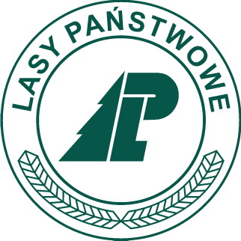](http://s1.manifo.com/usr/8/8C24/da/manager/logolp.jpg)

[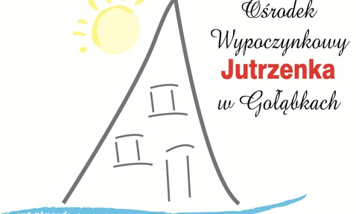](http://s2.manifo.com/usr/8/8C24/da/manager/golabki-logo.jpg)

[](http://s2.manifo.com/usr/8/8C24/da/manager/image001.gif)

[](http://kapi.org.pl/)

[](http://s2.manifo.com/usr/8/8C24/da/manager/logo-avaco-png.png)

[](http://s2.manifo.com/usr/8/8C24/da/manager/wegner_logo-czerwone489931474.png)

[](http://s1.manifo.com/usr/8/8C24/da/manager/cembrit-1-4c---kopia.png)

[](http://s2.manifo.com/usr/8/8C24/da/manager/pbs.jpg)

[](http://s2.manifo.com/usr/8/8C24/da/manager/bridgestone-logo-typea.jpg)

[](http://s2.manifo.com/usr/8/8C24/da/manager/newbalance.jpg)

.

[](http://s2.manifo.com/usr/8/8C24/da/manager/gaca454425328.png)

[](http://s1.manifo.com/usr/8/8C24/da/manager/pzp.jpg)

.